We supply:

1 to unlimited qualified jumpers for your event
(Plane costs accordingly).

Qualified ground person to supervise landing area and as a liaison with the jumpers.

Aircraft/pilot if required.

Smoke if wanted.

Air/space clearance from regional office of M.O.T.

Liability insurance through the Canadian Sport Parachute Association.

You supply:

Minimum 10 workdays notice to allow us to file for clearance from M.O.T.

Written permission from landowner

A suitable landing site free of hydro wires & Obstacles. It may be an empty field today, but will it be full of people/vehicles during your event?

A deposit to cover liability insurance, reservation of aircraft and jumpers, etc.

Flags or banners if you wish us to fly your event logo.

Contact us today to raise your event to a whole new altitude!

Descenders
Paraclub

Brian diCenzo
416-605-0010

Rob Price
705-835-2227

E-mail
descenders@dicenzo.ca

Web
www.dicenzo.ca/descenders
The
Descenders Paraclub
Can Land at Your Event!

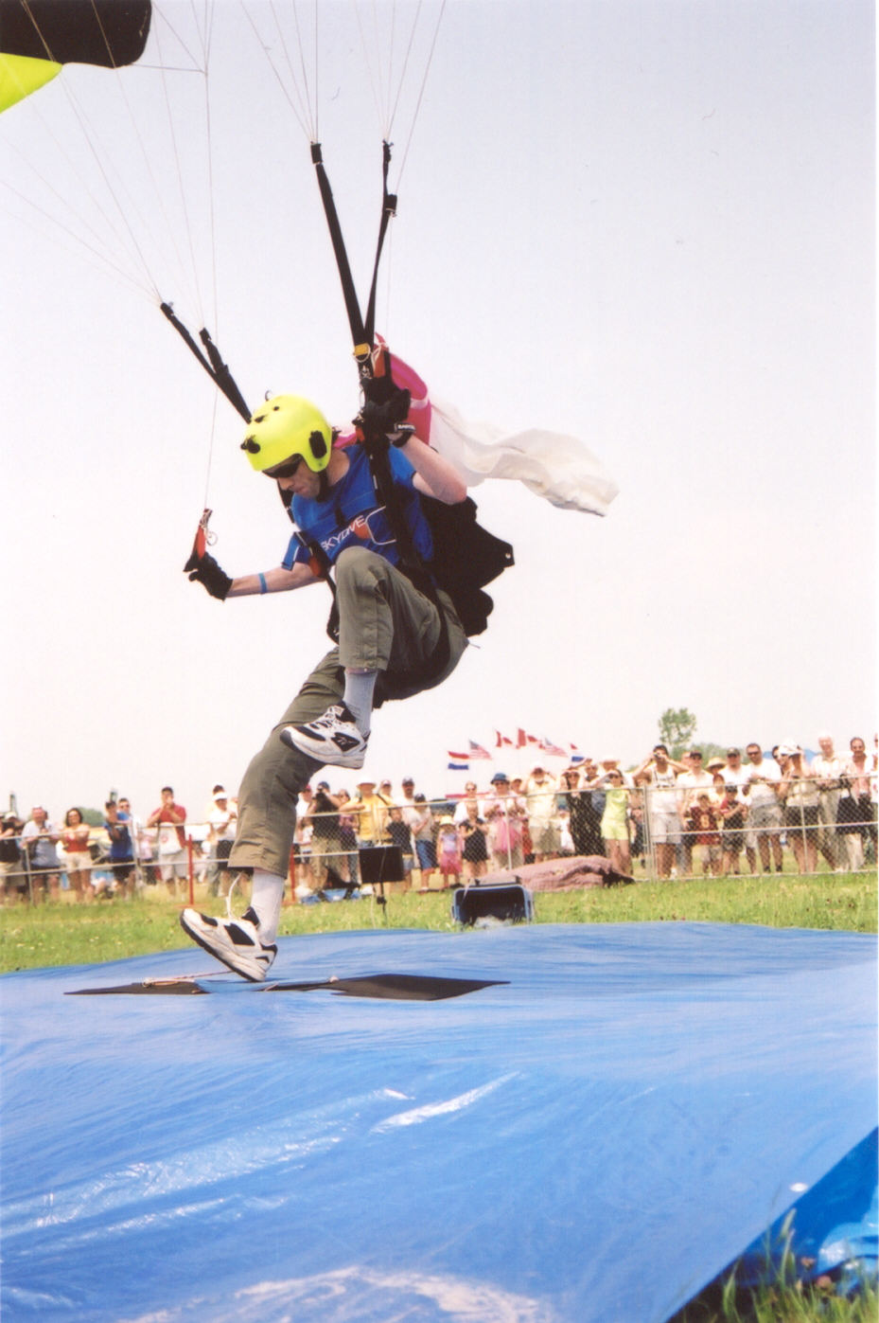
Peter Chapman landing at Oshawa Air show.
(Rob Price Photo)
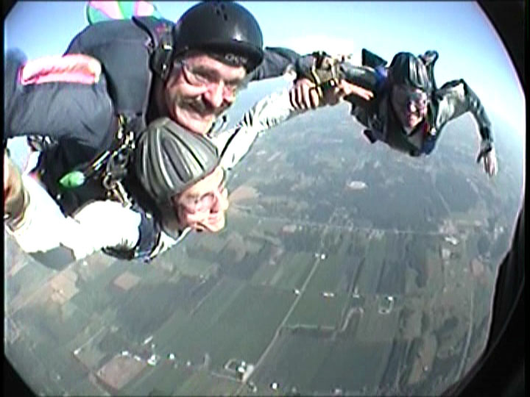
Brian diCenzo and his son George are joined by Rob Price over Skydive Toronto near Cookstown, Ontario
(Tiffany Surerus in-air camera)

Rob is an instructor, tandem master and parachute rigger with over 2800 jumps. Rob was on the Labatt’s ‘Out of the Blue’ Skydiving Team and participated in Canadian large formation records in 2004 and 2006.

Rob and Brian started competing against each other in the early 1980’s before performing together at venues such as the Canadian International Air Show, the Hamilton Air Show, the Toronto Molson Indy and the opening ceremony of the Skydome.

Brian is an instructor and tandem master with over 2900 jumps, and has been organizing annual exhibition jumps for Toronto’s Polo for Heart charity for over 27 years. He was also on the original Labatt’s Blue Sky team.
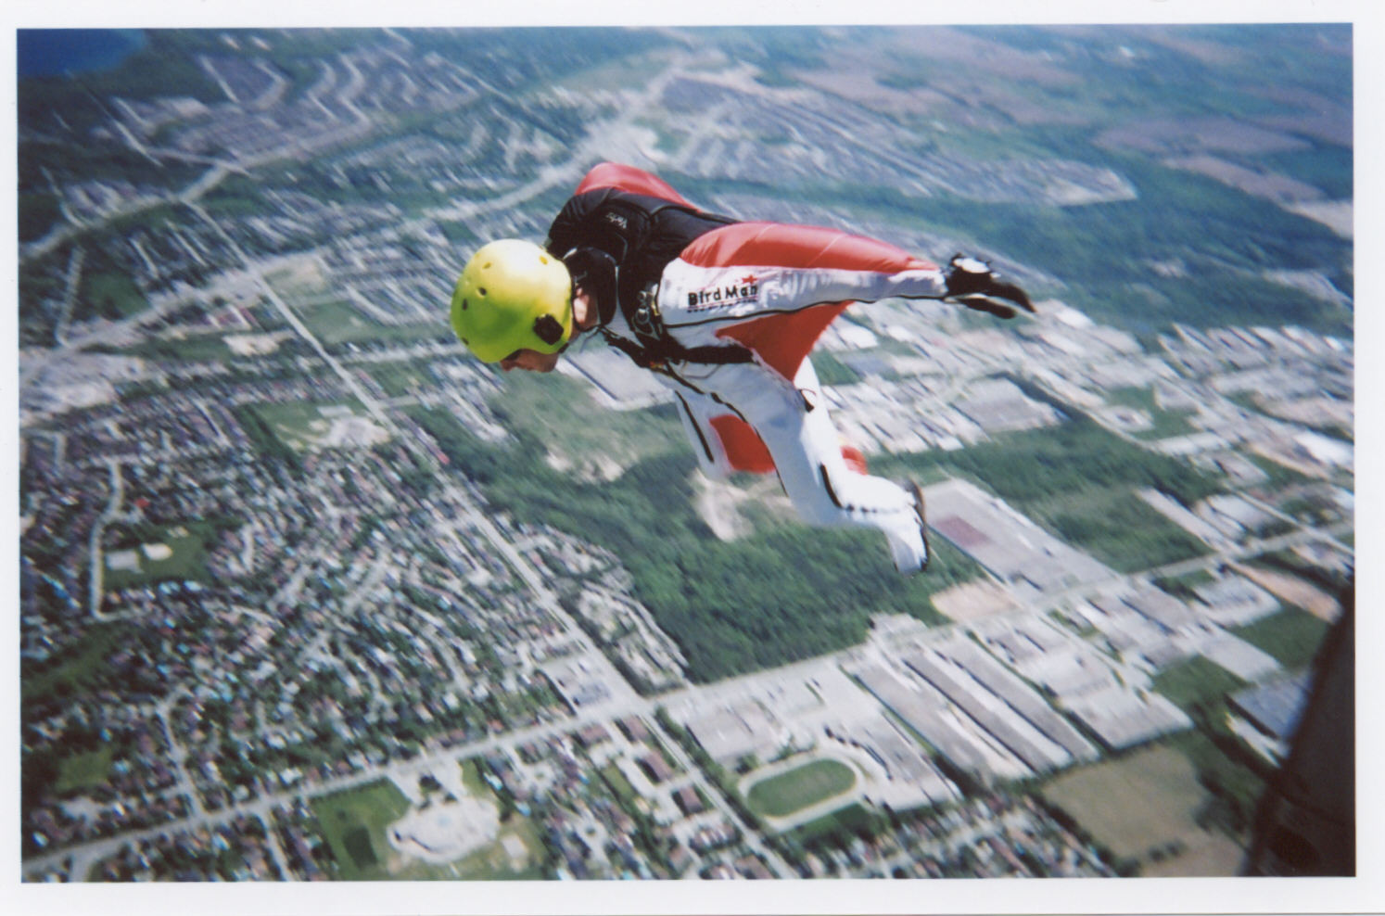
Peter Chapman exits over the Outdoor Adventure Show at the Barrie Event Centre, 2006
(Rob Price photo)

Peter is an instructor, tandem master and parachute rigger with 1500 jumps. He was a member of the Canadian Parachute Team at the 2003 World Meet in France.

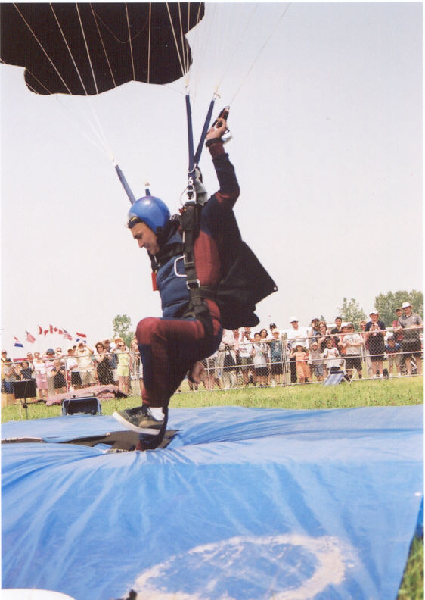
Lukacs Hatvani at Oshawa Air show
(Rob Price photo)

Lukacs Hatvani is an instructor, tandem master and parachute rigger with over 3000 jumps. He was on the Canadian Parachute Team that competed in Russia in 2006.
As instructors at Skydive Toronto near Cookstown, Ontario, we have access to a large pool of qualified skydivers to fulfill your event’s requirements.

Our members can make your event more exciting and visually appealing by jumping out thousands of feet in the air before floating to a soft landing near centre stage. Our jumps can add to your spectators’ experience, or to film and print media about the event.
. 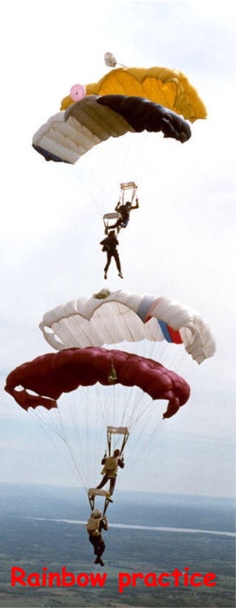
(Bill Pollock photo)

